Models of cloud computing.

**Aim:-**To study about models of cloud computing.

**Theory:-** [**Cloud Computing**](https://www.bluepiit.com/blog/how-cloud-computing-benefits-your-business/) is a model for enabling ubiquitous, convenient, on-demand network access to a shared pool of configurable computing resources (e.g., networks, servers, storage, applications, and services) that can be rapidly provisioned and released with minimal management effort or service provider interaction.  
Read more about some of the core [cloud computing benefits for your business](https://www.bluepiit.com/blog/why-performance-parameters-matters-in-cloud-computing/).

***Based on a service that the cloud is offering, we classify as:***

* **IaaS**(Infrastructure-as-a-Service)
* **PaaS**(Platform-as-a-Service)
* **SaaS**(Software-as-a-Service)

**Infrastructure As A Service (IAAS)**

Infrastructure as a Service (IAAS) is a form of cloud computing that provides virtualized computing resources over the internet. In an IAAS model, a third party provider hosts hardware, software, servers, storage and other infrastructure components on the behalf of its users. IAAS providers also host users’ applications and handle tasks including system maintenance backup and resiliency planning.  
IAAS platforms offer highly scalable resources that can be adjusted on-demand which makes it a well-suited for workloads that are temporary, experimental or change unexpectedly. Other characteristics of IAAS environments include the automation of administrative tasks, dynamic scaling, desktop virtualization and policy-based services. Other characteristics of IAAS include the automation of administrative tasks, dynamic scaling, desktop virtualization and policy-based services.  
Technically, the IaaS market has a relatively low barrier of entry, but it may require substantial financial investment in order to build and support the cloud infrastructure. Mature open-source cloud management frameworks like OpenStack are available to everyone and provide strong a software foundation for companies that want to build their private cloud or become a public cloud provider.

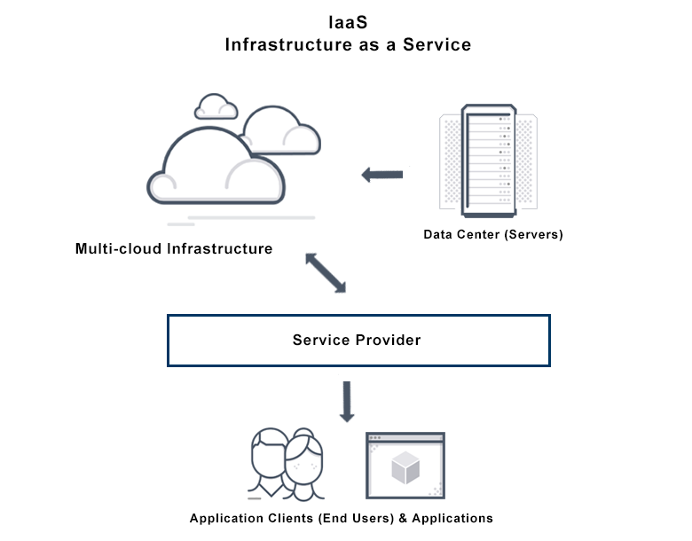

**Platform As A Service (PAAS)**

Platform as a Service (PAAS) is a cloud computing model that delivers applications over the internet. In a PAAS model, a cloud provider delivers hardware and software tools, usually those needed for application development, to its users as a service. A PAAS provider hosts the hardware and software on its own infrastructure. As a result, PAAS frees users from having to install in-house hardware and software to develop or run a new application.

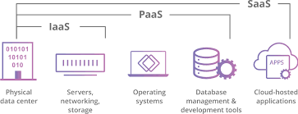

**Software As A Service (SAAS)**

Software as a Service(SAAS) is a software distribution model in which applications are hosted by a vendor or service provider and made available to customers over a network, typically the Internet. SAAS has become an increasingly prevalent delivery model as underlying technologies that support Web services and service-oriented architecture (SOA) mature and new development approaches, such as Ajax, become popular. SAAS is closely related to the ASP (Application service provider) and on-demand computing software delivery models. IDC identifies two slightly different delivery models for SAAS namely the hosted application model and the software development model.

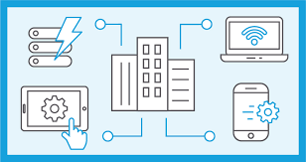

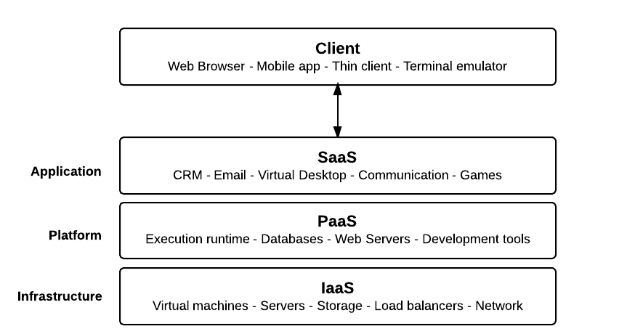

***Conclusion :***- In **conclusion**, **cloud computing** is recently new technological development that has the potential to have a great impact on the world. It has many benefits that it provides to it users and businesses.